
International School

Capstone Project 1
CMU-SE 450

Database Design
Version 1.1
Date: 16/11/2021

Online Clinic Booking System

Submitted by

Truong Gia Huy
Ngo Van Kha
Le Van Xuan
Tran Nguyen Thanh Hong

Capstone Project 1 - Mentor
Master Nguyen Tan Thuan Date:
Signature:


Project Information

Project acronym | OnClinic
Project Title | Online Clinic Booking System
Start Date | 23 Aug 2021 | End Date | 12 Dec 2021
Lead Institution | International School, Duy Tan University
Project Mentor | Master Thuan, Nguyen Tan  Email: thuannt.it.dtu@gmail.com
Scrum master / Project Leader & contact details | Ngo Van Kha – 24211210573  Email: ngokha437@gmail.com  Tel: 0935950384
Partner Organization | N/A
Team Members
Student ID | Name | Email | Tel
24211206450 | Truong Gia Huy | truonggiahuy7799@gmail.com | 0972173687
24211207159 | Le Van Xuan | levanxuan5518@gmail.com | 0905596460
24207106137 | Tran Nguyen Thanh Hong | thanhhong24102000@gmail.com | 0782363961

Document Infomation

Document Title | Database Design
Reporting Period
Author(s) | Ngo Van Kha, Le Van Xuan, Truong Gia Huy
Team members | Name:
Team members | Ngo Van Kha
Team members | Le Van Xuan
Team members | Truong Gia Huy
Team members | Tran Nguyen Thanh Hong
Date | 16/11/2021
File name | C1SE.37-DatabaseDesign-OnClinic
Access | Project and CMU Program

Document History
Version | Date | Comments
V1.0 | 04/9/2021 | Create Database Design
V1.1 | 16/11/2021 | Update, complete the document

TABLE OF CONTENT
Project Information 1
Document Infomation 2
1. Introduction 4
1.1. Purpose 4
1.2. Goal 4
1.3. Scope 4
1.4. Data storage platforms 5
1.5. Definition, Acronyms and Abbreviations 5
2. Database Design 5
2.1. Table Overview 5
2.2. Entity Relationship Diagram 0
2.3. Table Relationship Diagram 7
2.4. Detail 8
2.4.1. NguoiDung 8
2.4.2. BenhNhan 8
2.4.3. BacSi 8
2.4.4. PhongKham 8
2.4.5. LichKham 9
2.4.6. LichSu 9
2.4.7. DonThuoc 9
2.4.8. Benh 10
2.4.9. DanhGia 10
2.4.10. ThongBao 10

Introduction

Purpose
Place information system’s database design document describes structure of database and file structure of system. Database Design document will introduce all attribute the System that will help developer and tester base on this design to implement and test.

Goal
To create database tables most accurate.

Scope
This Database Design Document provides the basic for “OnClinic” Database design.
It describes both logical and physical definition, non-functional issues, and the database interfaces; storage aspects are defined in the physical database design sections.
The tables performance considerations requirements. The following topics are covered in this document:
- Assumptions and decisions on database design.
- Entity-mapping.
- Table column definitions.
- Primary, unique and foreign key definitions.
- Column and row level validation rules (check constraints).
- Rule for populating specific columns (sequences, derivations, demoralized (column)).
- Interfaces and dependencies with other components.
- Data access description.
The database design is composed of definitions for database objects derived by mapping entities to tables attributes to columns, unique identifiers to unique keys and relationships to foreign keys.
During design, these initial definitions are enhanced to support the functionality described in the functional specification/ user stories and defined in the primary and supporting modules of the application high level design.

Data storage platforms
- Data of application is stored in PostgreSQL database
- In PostgreSQL, data structure is stored as tables that the database objects that behave as containers for the data, in which the data will be logically organized in rows and columns format.

Definition, Acronyms and Abbreviations
Abbreviations | Description | Comment
PK/FK | Primary/ Foreign Key | Use to indicate a file is a Primary or Foreign key in a table
ERD | Entity Relationship Diagram | Show the relationship between entities in the system

Database Design

Table Overview
No. | Table name | Short Description
1 | NGUOIDUNG | This table shows all information of User
2 | PHONGKHAM | This table shows all information of Clinic
3 | LICHKHAM | This table shows all information of Examination Schedule
4 | DONTHUOC | This table shows all information of Medicine
5 | LICHSU | This table shows all information of Medical History
6 | BENH | This table shows all information of Disease
7 | DANHGIA | This table shows all information of Vote and Evaluate

JSON Tree Structure
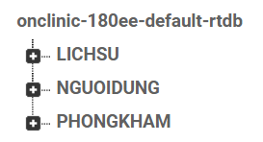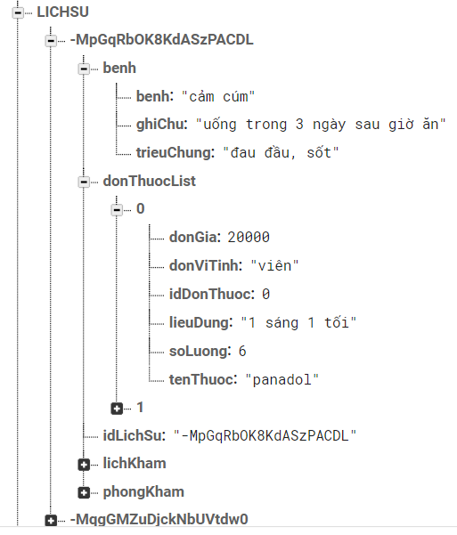

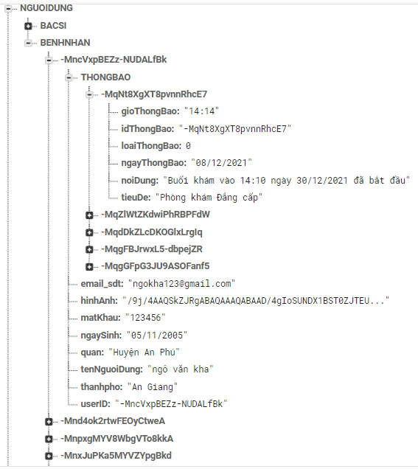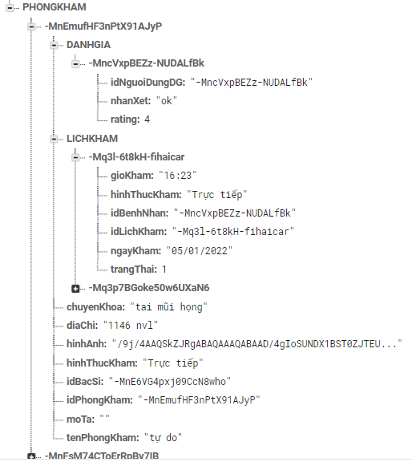

Entity Relationship Diagram
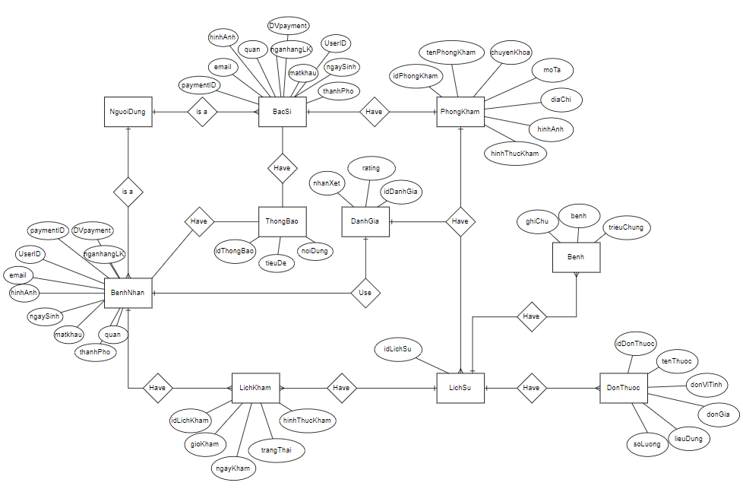

Table Relationship Diagram

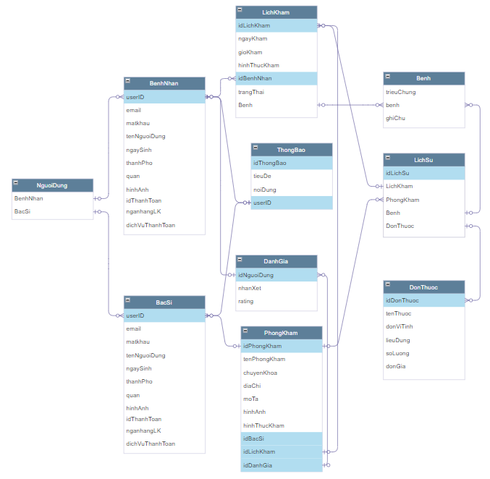

Detail

NguoiDung
Attributes | Datatype | Null | Key | Default | Extra
BenhNhan | object
BacSi | object

BenhNhan
Attributes | Datatype | Null | Key | Default | Extra
userID | String | Not | PK, FK
email | String | Not
matkhau | String | Not
tenNguoiDung | String | Not
ngaySinh | String | Not
thanhPho | String | Not
quan | String | Not
hinhAnh | String | Not
idThanhToan | String
nganhangLK | String
dichVuThanhToan | String

BacSi
Attributes | Datatype | Null | Key | Default | Extra
userID | String | Not | PK, FK
email | String | Not
matkhau | String | Not
tenNguoiDung | String | Not
ngaySinh | String | Not
thanhPho | String | Not
quan | String | Not
hinhAnh | String | Not
idThanhToan | String
nganhangLK | String
dichVuThanhToan | String

PhongKham
Attributes | Datatype | Null | Key | Default | Extra
idPhongKham | String | Not | PK
tenPhongKham | String | Not
chuyenKhoa | String | Not
diaChi | String | Not
moTa | String
hinhAnh | String | Not
hinhThucKham | String | Not
idBacSi | String | Not | FK
idLichKham | String | Not | FK
idDanhGia | String | Not | FK

LichKham
Attributes | Datatype | Null | Key | Default | Extra
idLichKham | String | Not | PK
ngayKham | String | Not
gioKham | String | Not
hinhThucKham | String | Not
idBenhNhan | String | Not | FK
trangThai | String | Not
Benh | String | Not

LichSu
Attributes | Datatype | Null | Key | Default | Extra
idLichSu | String | Not | PK
LichKham | object | Not | FK
PhongKham | object | Not | FK
Benh | object
DonThuoc | object

DonThuoc
Attributes | Datatype | Null | Key | Default | Extra
idDonThuoc | String | Not | PK
tenThuoc | String | Not
donViTinh | String | Not
lieuDung | String | Not
soLuong | String | Not
donGia | String | Not

Benh
Attributes | Datatype | Null | Key | Default | Extra
trieuChung | String | Not
benh | String | Not
ghiChu | String

DanhGia
Attributes | Datatype | Null | Key | Default | Extra
idNguoiDung | String | Not | PK
nhanXet | String | Not
rating | String | Not

ThongBao
Attributes | Datatype | Null | Key | Default | Extra
idThongBao | String | Not | PK
tieuDe | String | Not
noiDung | String | Not
userID | String | Not | FK

